Yucehan Kucukmotor

Lawrence Tatum, CIS3920, Exercise from LN1

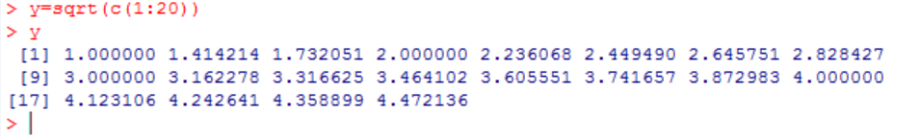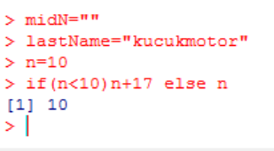

1.1

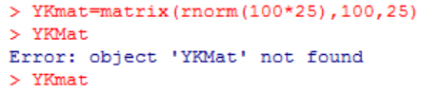1.2 I have created a Matrix named YKmat

(Yucehan Kucukmotor), and filled it with 100*25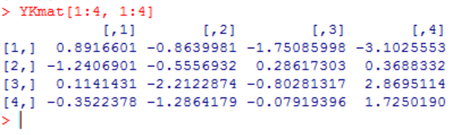standard deviates. I’ve used rnorm() to accomplish this. And, I’ve used numbers (…,100,25) at the end of the line to create 100 rows and 25 columns. Bottom picture on the right side is to show how I extracted first 4 rows and 4 columns. YKmat was the name I chose for my matrix. [1:4 is to extract first 4 rows and ,1:4] is to extract first 4 columns.

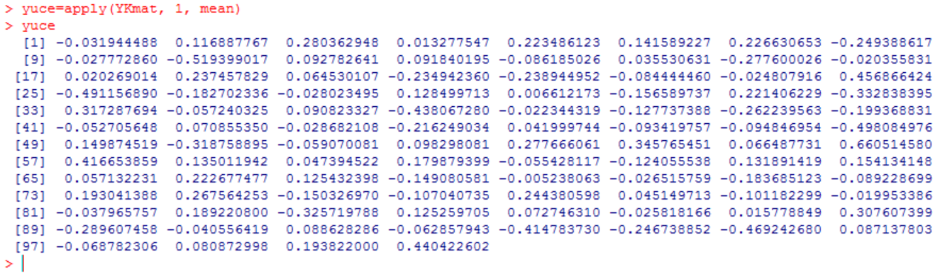1.3 given the name “yuce” to my output. YKmat is to call the matrix named “YKmat”, and “1” (number 1, not letter l) is to say that I want row information, and mean is to extract the average.

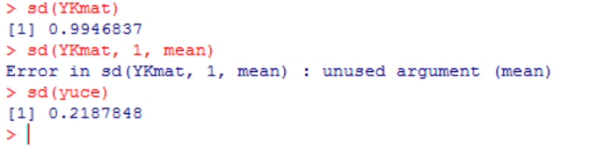

1.4.(a) I’ve made some obvious mistakes because I forgot that I had named my output yuce, and I was trying to play around with it as well.

1.4.(b) First line on the screenshot that is on the right side of the question 1.4.(a) – sd(YKmat)

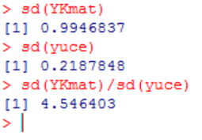#I’ve used sd function to find sample standard deviation.

1.4.(c) Earlier, I had named YKmat’s row averages “yuce”. Using the sd function once more:

sd(YKmat)/sd(yuce), we get 4.546403 as a result.

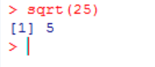

1.4.(d) Corresponding sample size in this practice is 2500. Using the sqrt() function (sqrt(n)=>sqrt(2500)=>50). 50 is not close to 4.546403 (above). Thus, statistical theory does not hold.

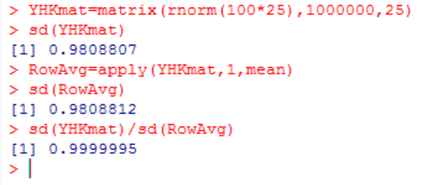1.5 a new matrix with 1,000,000 rows is created using the matrix() function. It is named YHKmat, slightly different than the matrix with YKmat so that I do not override it. YHKmat’s row average is found using apply() function and it is named RowAvg. Division of both values results in a number that is very very close to 1. Sample size is 1 and sqrt(1) yields 1. Statistical theory holds.

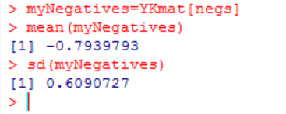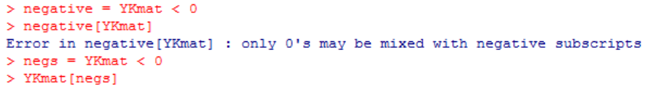1.6.(a) Above picture is to show a mistake I made. Instead of typing YKmat[negative], I typed negative[YKmat]. After realizing my mistake (thanks to the error I received), I

changed the name negs. I named that group of numbers (negatives within YKmat) “myNegatives”. Then I used mean and sd functions respectively.

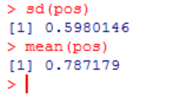C:\Users\Yucehan\AppData\Local\Microsoft\Windows\INetCache\Content.Word\1.6.3.png1.6.(b) named non negative numbers pos. then used sd() and mean() functions to find the sample standard deviation and mean. [!negs] \*\**Exclamation is to say non-negatives = positives*\*\*

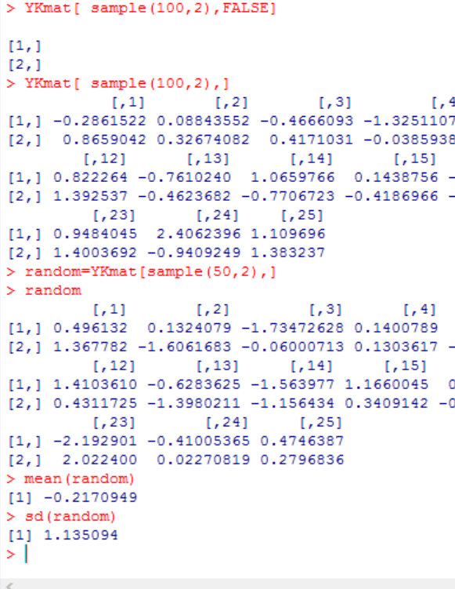1.7 Used sample functions to find 2 random numbers out of 100, and then 50 elements. Assigned the name random to the result and used mean and sd functions to find the results.

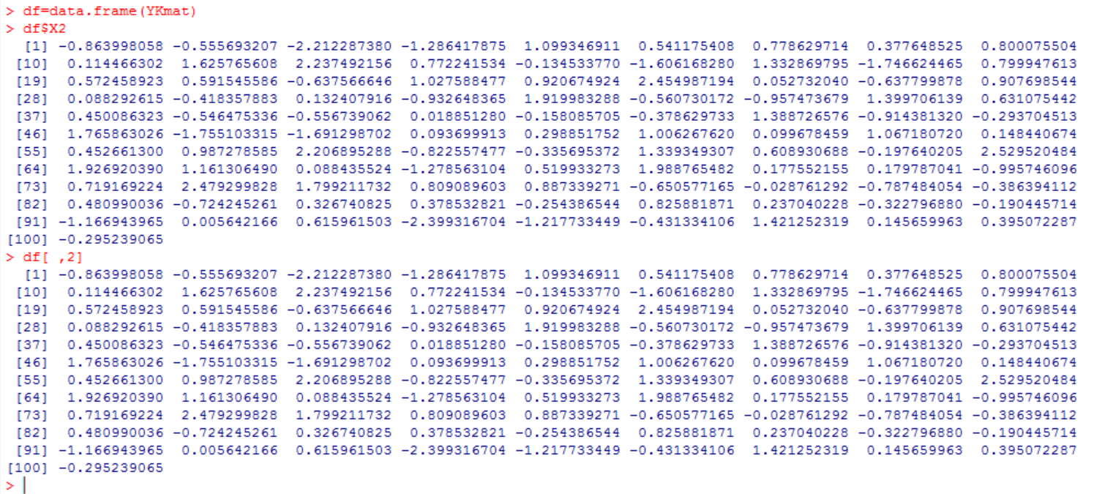1.8 Screenshot for this exercise is below. I named the dataframe df and using data.frame() function, extracting numbers from YKmat matrix that I had created earlier. Then I called second column using two different methods.

Once with df$X2 and then with df[,2]

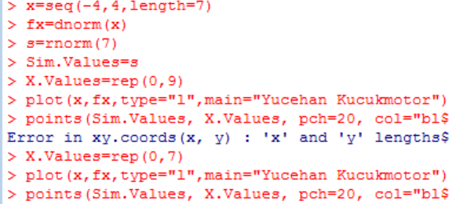

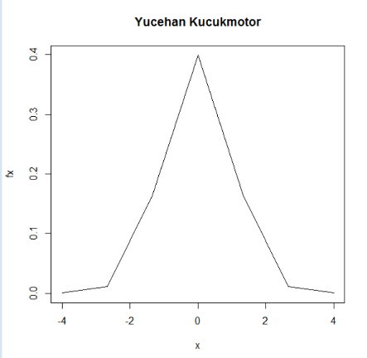

1.9 Points fall symmetrically. Top of the graph is not curved which is not a good sign. Sample size is too small (n=7). 95% seem to be falling between -2 and 2. We can say we have a standard normal distribution. **But it is not bell-curved.**